Latent Probabilistic Model of News Sources

Project Alpha Prototype Report

Army Cyber Institute





**Machine Learning for Media Bias**

William Hiatt, Gabriel Matthew, and Deven Biehler

02/21/2023

**TABLE OF CONTENTS**

**I. Introduction 4**

I.1. Project Introduction 4

I.2. Background and Related Work 4

I.3. Project Overview 5

I.4. Client and Stakeholder Identification and Preferences 6

I.5. Definitions 6

**II. Team Members - Bios and Project Roles 7**

**III. Project Requirements 8**

III.1. Spike Stories 8

III.1.1. Determine tools and libraries needed for our model 8

III.1.2. Develop main model 8

III.1.3. Measuring Bias 8

III.1.4. Fact-Checking and Subjectivity 8

III.1.5. Topic Modeling 9

III.2. Functional Requirements 9

III.2.1. Sentiment Analysis 9

III.2.2. Topic Modeling 9

III.2.3. Similarity Analysis 9

III.3. Non-Functional Requirements 10

Reliability/Accuracy 10

Extensibility 10

Usability 10

Content-Focused 10

Comprehension 10

**IV. Software Design 10**

IV.1. Architecture Design 10

IV.1.1. Overview 10

IV.1.2. Model Input 12

IV.1.3. Data Scraping/Cleaning 12

IV.1.4. Topic Modeling Analysis 12

IV.2. Data Pipeline Design 14

IV.2.1. Incoming Data 14

IV.2.2. Data processing 14

IV.2.2.1. Pre-Scrape check 14

IV.2.2.2. Scraping 15

IV.2.2.3. Post-Scrape check 15

IV.2.3. Data management 15

IV.3. User Interface Design 16

**V. Test Plan 16**

**VI. Functional Test Cases 16**

Test Case ID: 1.1 16

Test Case ID: 1.2 17

Test Case ID: 1.3 18

Test Case ID: 1.4 19

Test Case ID: 2.1 20

Test Case ID: 2.2 20

Test Case ID: 2.3 21

Test Case ID: 3.1 22

Test Case ID: 3.2 23

**VII. Non-functional Requirements Testing Strategy 24**

**VIII. Test Case Specifications and Results 24**

Database Variance Testing and Validation 25

Forms of Validation 25

**IX. Staging and Deployment Plans 28**

**X. Final Prototype Description 28**

Problem Statement 28

Solution approach 29

X.1. Data Collection 30

X.1.1. Functions and Interfaces Implemented 30

X.1.2. Preliminary Tests 30

X.2. Topic Modeling 30

X.2.1. Functions and Interfaces Implemented 30

Preliminary Tests 31

X.2.2. Sentiment Analysis 31

Functions and Interfaces Implemented 31

Preliminary Tests 31

X.3. Data Visualization 31

Topic Space and Topic Sentiment Visuals 31

Main Topic Sentiment Analysis 32

Topic Subjectivity vs Sentiment 32

TSNE Dimension Reduction and Clustering 33

K-Means Clustering 34

**XI. Conclusions and Future Work 35**

XI.1. Conclusions 35

XI.2. Future Work 35

**XII. Repository Information 36**

XII.1. Repository URL 36

XII.2. Last Commit 36

XII.3. Contributors Names and Github Usernames 36

**XIII. References 36**

**XIV. Acknowledgements 37**

# Introduction

This document serves as a guide to the Latent Probabilistic Model of News Sources. It will present new and updated details of the current state of the project as well as the direction the project is going. It will include information such as the social science aspects of the project, the open source tools we will be using, models we will be creating, research that we will be using and research we will be doing internally, and any requirements that we currently have. This document will quickly go over the bio’s of group members on the team that are working on developing the model as well as all the stakeholders that the project will affect. This document serves as an explanation of the project’s function, purpose, and methods at the time this document was written.

## Project Introduction

The US Army Cyber Institute needs a method for evaluating a media landscape that does not rely upon expert opinions, subjective interpretations, or knowledge of internal publishing practices. This model will be used to understand the articles and publishers within a media landscape, based on a statistical measure of their biases of topics within the articles. The model will measure major topics and the bias surrounding them within news articles, and return a visualization of the news landscape regarding the topics and the sources reporting on those topics. With this method the Army will be able to better understand information environments. The end goal of this project is to create a new method for the Army that can take in individual news articles from various sources and produce a model of those news sources, based on their articles, which can then be aggregated to a model of the media ecosystem of those news sources. Given that the major differences between news sources is what they choose to talk about (e.g. topic bias) as well as how they choose to talk about those topics (e.g. framing, word choice bias), the basis of the model will utilize topic and sentiment as its primary means of characterization. The model will establish an ecosystem of news articles and sources that is based on biases and sentiment values based on the major topics within each article. This ecosystem will be displayed graphically for the user to make insights about the data. The model will use a mixture of currently available software as well as software created by the team.

## Background and Related Work

Concerns about media bias and its potential impact on society have grown in recent years. Misinformation, polarization, and even discrimination can result from biased news. The information domain, of which the media landscape is a major component, is a critical domain to the success of modern military operations. This has led to the development of NLP tools and software that can accurately predict various information about news articles, such as political stance and subjectivity of an article.

A public tool that is in line with this project is the media bias detection in AllSides(allsides.com, 2022). Their website, allsides.com, provides free bias ratings on major current events, as well as displays articles from multiple political sides. They use a combination of patented news software with a variety of manual methods, like third-party blind surveys and editorial panel reviews, to display the political stances of each side on a topic. They also include key quotes and context, as well as a link to each article in full. This is important for this project because it shows a publicly available tool that functions in a more manual way than this project’s software.

Another similar tool is Media Bias/Fact Check through the website mediabiasfactcheck.com(mediabiasfactcheck.com, 2021), which is a public manual service that shows media bias as well as performs fact-checking on major news sources in their database. They rely on a combination of 3rd-party services as well as professional reviews to produce their results, which means their data is generated mostly manually. They provide an in-depth explanation of the methodologies used to rate the articles’ media biases, and how it translates onto a spectrum of bias.

There is a multitude of research being performed on topics similar to this project’s focus. For example, in “Machine-Learning media bias”(Samantha D'Alonzo, 2021) published out of M.I.T, they present an automated method of media bias that maps newspapers on a two-dimensional scale of left-right bias and establishment bias. They also map topics within those articles to show how the word choice of topics affects the bias authors have. M.I.T’s study is very similar to this project in that they effectively mapped a media landscape regarding the topics and sources of news articles.

Another similar study is “Detecting Media Bias in News Articles using Gaussian Bias Distributions”(Wei-Fan Chen), uses sentence-level bias detection software to feed into a model that produces article-level biases based on the topics covered. They use a term second-order bias information to measure at the article level, which they define as the frequency and position of biased statements regarding a topic. This helps them create a model of the bias within an entire article. This work parallels our project, with the major difference being their reliance upon second-order bias information to produce article-level bias analysis.

## Project Overview

The media has a huge duty in the form of distributing news to the American public. The information plays a huge role in how people vote. The current offerings in characterizing media bias aren’t as detailed as they should be and still contain a bias in themselves as it’s often a human who is assigning these biases. For example, allsides.com has CNN ranked as far left while adsfontesmedia.com has them as slightly left leaning. This is just a single example, but it shows that there is even a bias within deciding bias. In addition one post from a media outlet could contain no bias and be factually correct while another may contain a lot of bias and not be factually correct; the labels assigned to a media source are in practice overly simplistic and media sources are more probabilistic than deterministic in their displays of bias. Finally, current methods of characterizing bias or media landscape are context-bound; the same methods and measures to assess the bias in media landscapes in the United States may not translate to other media landscapes, like those in other countries or regions of the world. The goal of the team is to combat this by creating a model that can model news sources in a probabilistic way, using recent research into bias and topic modeling in order to create an purely empirically driven way, that does not require human subjective judgements, to characterize a media landscape.

The team, with the help of mentors at the Army Cyber Institute(cyber.army.mil), will create a new method that will address the issues presented in the current media landscape, with a focus on bias . Through research, designing, building, and testing the team will deliver a media landscape assessment tool to help fight information warfare.

The project is being built from the ground up. There are no limitations on how we create the model. The team has decided to use Python to create the model. Python is extremely popular for machine learning and will be a great platform to use. The code will be housed on GitHub, this allows for easy version control and collaboration.

Using Python allows for the use of some popular tools. Some tools the team will be using include, spaCy(spacy.io) for natural language processing, Gensim(radimrehurek.com/gensim) for topic modeling, textBlob(textblob.readthedocs.io) for sentiment analysis, Pandas(pandas.pydata.org) for managing data, and Newspaper3k(newspaper.readthedocs.io) for web scraping. These tools will all be used in conjunction to create a model that fits the needs of the client.The team will be using sentiment analysis and fact selection as the primary drivers in deciding a bias. As the project progresses, we plan to include additional secondary drivers.

## Client and Stakeholder Identification and Preferences

Our client is the US Army Cyber Institute(cyber.army.mil) with Senior Research Scientist Iain Cruickshank as our mentor and primary contact for the project. The product will be used and maintained by the Army. There are several stakeholders within the Army Cyber Institute including Iain and his colleagues.

## Definitions

FR – Functional Requirement.

NFR – Non-functional Requirement.

Article-level Model – The first model in our overall project that refers to the process of gathering single articles, and performing both sentiment analysis and topic modeling on the articles to pass into the next model. Also gathers metadata relating to author, source, and date written. The model does this for every article in the database provided.

Article Comparison-level Model – The second model and intermediary step of the project. This model makes comparisons between separate articles and calculates similarity between articles based on their topics and sentiment around those topics. This model will pass its data on to the final model, the ecosystem-level model.

Ecosystem-level Model – The final model of the project and the model that takes in data from the other two previous models. Given that data, this model compares and sorts both articles based on their topic and sentiment similarity, and displays it in a comprehensible way for the user. The model will also filter the data and show smaller subsections of the dataset to provide the user with smaller-scale comparisons. The idea behind this model is to display the ‘ecosystem’ of articles by showing how they all compare to each other and fit on a scale of sentiments on their topics.

Sentiment Analysis– Sentiment of a news article is the general idea of the attitude or view of an article. It describes whether the article takes a positive or negative position, as well as the subjectivity of the statements made in an article. Sentiment analysis uses a probabilistic model to look at what an article’s sentiment is and quantify it into a numerical value. In simplest terms, a positive sentiment analysis value corresponds to a positive or nice article, while a negative value corresponds to a negative or mean article. 0 usually corresponds to a neutral article.

Topic Modeling– A topic in an article is represented in our model by a list of words that together create a cohesive idea (for example, a topic involving cars could have the following topic words: tires, MPG, model, drive, Ford.) Topic modeling involves finding common topics between multiple articles in our model, and creating a group of topics that together cover the most common topics found in all articles.

Topic Clustering– As part of our data visualization, topic clustering involves taking articles and their [associated topics, and using clustering algorithms to group articles by their shared or unique topics. Articles that share many topics are generally clustered together, while articles that differ greatly in their topics are represented as further away from each other.

LDA model– Our main method for performing topic modeling. LDA stands for Latent Dirichlet Allocation, and in simple terms this model finds the common topic words within all articles and groups them into separate topics. Those topics are representative of the common topics that at least some of the articles share in our model. Also generates relevancy scores for articles that tell us how relevant a topic is to a given article, as well as other values relating to the topics and articles.

Topic-Weighted Sentiment Analysis– Given the sentiment analysis values as well as our topic model, we can perform sentiment analysis on articles for just a single topic (for example, we could find the sentiment of a news article just about the topic of cars.) With that and a value that tells us the relevancy of our topic to an article, we can give a weighted score of how an article discusses a topic based on how relevant that topic is to the article. With this information we generate a visualization that shows us both the topic clustering for each article and the sentiment they have for each topic.

Probabilistic Model– A statistical model that takes in seemingly random or unstructured data and uses that to predict future outcomes involving the data. In our specific model, we use this unsupervised model to generate an article space that doesn’t predict future results, but gives insight into the unstructured data involving article topics and their sentiment around those topics.

TSNE– t-distributed stochastic neighbor embedding is an unsupervised dimension reduction technique used to visualize high-dimensional data. We use it to reduce the multiple dimensions of topics within each article into a 2D space that we can display how closely each article is related (by topics discussed) to other articles in the space.

K-means– a clustering method, which helps us to partition documents into a number of clusters that are related by topic. It also takes in our high-dimension topic data and clusters articles together by which article is closest to the center of a cluster. We use this to generate a topic space in 2 dimensions.

Webscraping– The process of taking a URL and programmatically gathering all of the text on the webpage for use in our model. For example, webscraping a New York Times article would use the article URL as input, and the output would be the text body of the article.

# Team Members - Bios and Project Roles

William Hiatt is a 4th year software engineering student at Washington State University. His skills include C#, Python, SQL, Java, C++, and GoLang. He has prior experience working as a software engineer intern at Kochava as well as a junior web developer at Washington State University. For this project, William will act as a team lead, main developer and designer of the model, and work with his team to create a viable machine learning model.

Gabriel Sams is a 4th year Computer Science major at Washington State University. His skills include C#, Python, Database development/management, SQL, machine learning, software development, agile process, test-driven development, and data science. His prior experience includes mobile application development, database development and management, and unit, end-to-end, and functional testing. For this project, Gabriel will act as a main developer and designer of the model, and work with his team to create a viable machine learning model.

Deven Biehler is a 4th year Computer Science major at Washington State University. His skills include C/C++, Python, SQL, machine learning, HTML/CSS, agile process, and data science. For this project, Deven will act as a main developer and designer of the model, and work with his team to create a viable machine learning model.

# Project Requirements

## Spike Stories

## Determine tools and libraries needed for our model

Determine the tools to be used for sentiment analysis/textual analysis. Users will be able to view per-article data gathered from NLP and sentiment analysis. The data will be clearly displayed and comprehensible so the user can interpret it in a professional setting. Our team will need to determine open-source tools that will provide the highest accuracy and reliability to our data.

## Develop main model

Develop a usable model of media bias detection, by creating a data pipeline. The user will be able to gather useful data from three compounding levels of analysis. The tool itself will focus on displaying the “news ecosystem” for users, so the previous layers need to provide useful data to construct it. We will explore and develop algorithms to compile meaningful results at every level of news bias modeling.

* + - 1. **Sentiment Analysis step**

Create the base model for our software, that takes a single document and provides data on its sentiment of topics within the text as well as factuality of the documents. This model will be used to build a larger corpus of data for many separate documents.

* + - 1. **Topic Modeling step**

Develop a model that compares single documents to each other to find matching topics, and sentiment on a per-topic basis. These comparisons will be stored to create a larger ecosystem of article comparisons.

* + - 1. **Article and Topic Comparison**

Building from the per-article model, create a model that compares and displays the overall ecosystem of articles and how they relate to each other on a certain topic. The model will compare sentiment and factuality based on the models’ textual sentiment analysis and group them/sort them in a meaningful way.

* + - 1. **Data Visualization**

The final model must be able to categorize and sort the articles to show meaningful relationships between articles that match topics. Develop visualizations to meaningfully sort the article ecosystem into a graph that is comprehensible to the users.

## Measuring Bias

Find the most meaningful ways of measuring bias in text. Users will need the most accurate bias data for each topic. By researching and talking with social science professionals the team will create the most effective way at measuring bias so that the users have the most accurate information available. In the beginning only a couple different forms of bias will be evaluated with plans to expand in the future.

## Fact-Checking and Subjectivity

Explore methods of fact-checking as well as opinion recognition. Users will need to see when an article is falsifying data or otherwise lying to promote a bias. Fact-checking is an essential point of data when determining the motives of a particular article or source. We want to research possible ways of assessing the validity of a fact. Fact-checking will allow us to determine if a piece tries to persuade a user into a specific worldview. If we can find the lies, we can detect future lies that could be told in articles yet to be published.

## Topic Modeling

Determine tools to be used for topic modeling. In order to determine the bias per topic, we need a model to extract the topics from the articles. The topics will be extracted from each article and displayed each with a range of sentiment, ranging from positive or negative toward the topic.

## Functional Requirements

## Sentiment Analysis

**Per Topic:** Using a pre-trained natural language processing model, we receive an emotionality score towards an array of topics. Sentiment analysis is crucial to predict the emotional bias towards a specific topic.

**Source:** Senior Program Manager with Army Cyber Institute originated this requirement. The requirement is necessary for the bias analysis.

**Priority:** Priority Level 2: Essential and required functionality

**Per Article:** We receive an emotionality score towards the entire article using a pre-trained natural language processing model. The goal is to give the model more crucial data about the article's topic.

**Source:** Senior Program Manager with Army Cyber Institute originated this requirement. The requirement is necessary for the bias analysis.

**Priority:** Priority Level 2: Essential and required functionality

**Per Source:** Using a custom-built machine learning model, we can determine where the source will lay in the entire ecosystem of media news sources. The goal is to allow a user to understand the worldview of a source within the media ecosystem.

**Source:** Senior Program Manager with Army Cyber Institute originated this requirement. The requirement is necessary for the bias analysis.

**Priority:** Priority Level 2: Essential and required functionality

## Topic Modeling

**Modeling Relevant Topics:** Determining the topics is essential to model a per-topic bias analysis. The model learns bias towards an array of topics to portray the media ecosystem to the end user.

**Source:** Senior Program Manager with Army Cyber Institute originated this requirement. The requirement is necessary for the bias analysis.

**Priority:** Priority Level 2: Essential and required functionality

## Similarity Analysis

**Similar Article Analysis:** When learning the bias of specific sources, we can use their similarities to other sources to predict missing values. The model will look for any blatant copying from sources and take it as valuable data to make accurate predictions.

**Source:** Senior Program Manager with Army Cyber Institute originated this requirement. The requirement is necessary for the bias analysis.

**Priority:** Priority Level 1: Required for an accurate model

## Non-Functional Requirements

### Reliability/Accuracy

This tool should most importantly provide accurate and reliable information based on the input given. The tool should provide the same results for the same input every time, as well as provide data that is usable in a professional news media environment.

### Extensibility

This tool will be extensible to other domains within online media, including other languages and other political environments. While the tool itself will only work for English language and American news sources, it will allow for the insertion of new tools and libraries to adapt it to these new domains as its users see fit.

### Usability

This tool will aim to be usable by industry professionals and those who have domain knowledge of American news, but not necessarily any knowledge of Computer Science or how the tool functions in terms of programming. This means that the tool will include an instruction manual or other documentation that helps users work with the tool. The tool will be designed in an intuitive way.

### Content-Focused

This tool will focus on analyzing the actual content of news articles rather than the context surrounding them. The tool will analyze the text itself as well as relevant data and sources to make its calculations–it will not focus on the author, the timing of the article, or other contexts involving the news piece being analyzed.

### Comprehension

This tool will provide highly comprehensible data that can be interpreted by industry professionals to make professional decisions in a business setting. It will provide any relevant data to the user and will document any unreliable data or data that could be up to interpretation. Our goal is to be as transparent as possible about the reliability and usability of the data.

# Software Design

## Architecture Design

## Overview

Our project revolving around a latent probabilistic model of online news articles utilizes an architecture of three models. Each model builds upon the previous model, and together creates a finalized product. Our team decided on the 3-model approach due to the fact that our work is presented in multiple stages: article-level sentiment analysis and data gathering, article corpus-level topic modeling and localized sentiment analysis on topics, and sorting/filtering as well as data visualization. These three models can function separately from each other (given the correct data input) but together feed data through each stage which at the end provides meaningful insight into the article landscape it was provided. Here we provide an overview of each component in the diagram provided below, with details provided in the following sections. The web scraping component is the first step in our pipeline, that takes in a list of web article URLs and scrapes the article text from each of them, storing it inside a data structure in local memory. This component also filters out unwanted articles (any that give errors or are inaccessible,) and parses the text by sentence to better read it in. We then pass the web-scraped data through to our topic modeling component. In the topic modeling component, it takes the entire corpus of texts that we have stored from the previous components and applies topic modeling functions to them. This creates a topic space, in which all of the individual articles exist and relate/differ from each other based on topic words and topic prevalence within the articles. That data is then passed through to our sentiment analysis and parsing components, which calculates sentiment analysis on the text at various levels. It performs sentiment analysis on the entire article, as well as on localized portions of the article for individual topics to get a sentiment score for a topic within an article. Finally, after topic modeling and sentiment analysis has been performed, the processed data is moved into the visualization and UI component. This component produces interactable plots for the user to make assumptions on the topic space and sentiment around those topics. The user can search through the data to find specific topics, specific articles, and their associated sentiment analysis values. Extensive detail on these components can be found in the sections below. Directly below is a diagram of our system architecture layout.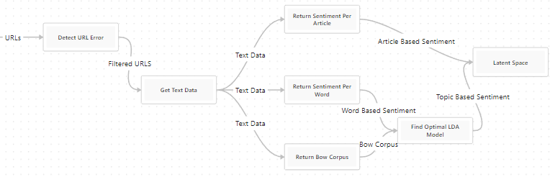

*Diagram IV.1 Software Architecture Overview*

## Model Input

The model will take in URLs of news articles in the form of a list, and will need to scrape the data from each URL to gather the title, author, and text of the article. The specific input will be a single news article that the model will run on. We think this is the best choice of data input due to a URL being simple to gather and run in the model, and that analyzing a single article at a time will make it easier to compile the data for many articles.

## Data Scraping/Cleaning

The model first reads in each URL from a CSV file and stores them in a dictionary. Each URL in the list is then run through Newspaper3k (https://newspaper.readthedocs.io) to scrape the web page. The gathered text is placed alongside each URL within the dictionary. Newspaper3k was chosen as it was the best web scraping tool for eliminating garbage such as ads, images, and other article links.The library is authored and maintained by Lucas Ou-Yang. Newspaper3k can scrape from 10+ different languages and can even auto detect languages. It extracts from html and can extract things such as text, top image, and all other images in the article. Once it’s extracted it can then go through the text and extract information such as keywords, summary, author, and google trending terms. Newspaper3k also uses a lot of python-goose’s parsing code. Python-Goose(github.com/grangier/python-goose) is a library that extracts information such as main text from an article, main image of an article, article descriptions, and more. Python-Goose was rewritten by Xavier Grangier.

The text is then stripped of any white spaces. Then the data is loaded into SpaCy(spacy.io). SpaCy then uses TextBlob(textblob.readthedocs.io) to run the sentiment analysis. After it has looped through every URL it then is saved into a dictionary with columns for Sentiment Score, Sentiment Label, Positive Words and Negative Words.

This process allows for easy usability as the user only needs to input the URLs of the news articles without having to worry about scraping the data themselves.

## Topic Modeling Analysis

Will use Gensim(radimrehurek.com/gensim), a Python package, for topic analysis. The model needs to extract topics from each article to be able to categorize it within our media ecosystem. We picked Gensim because of its efficient implementation, and because it provides the LDA(Latent Dirichlet allocation) topic model algorithm. LDA has the ability to assign multiple topics to a single document, along with a relevance score for each topic on the article. LDA can also be customized with various parameters to optimize for particular use cases. This adaptability can be beneficial in detecting news bias, where various topics or biases may necessitate different modeling strategies.

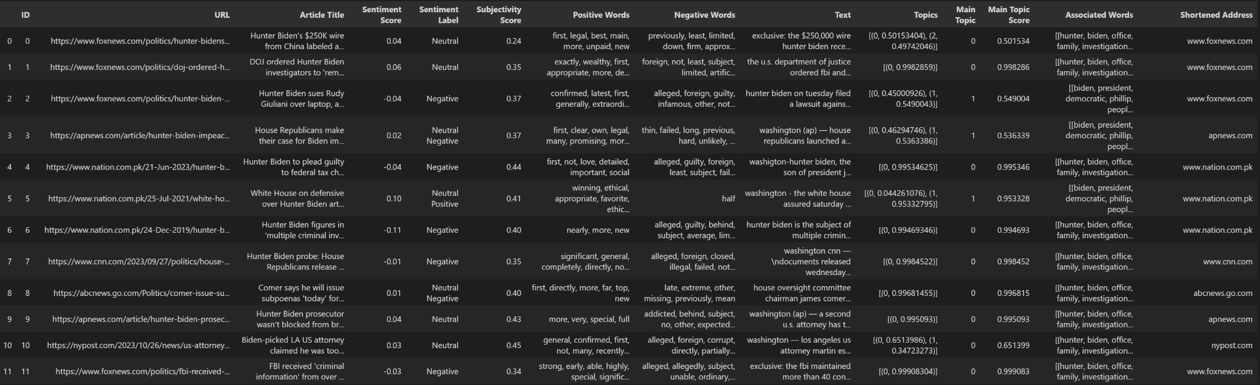

* + 1. **Sentiment Analysis**

Will be using SpaCy(spacy.io) as our Sentiment analysis tool, as well as the TextBlob(textblob.readthedocs.io) library within Spacy. The model will take in the article’s text and perform an overall sentiment analysis on the article and return a polarity sentiment score (it also returns a ’subjectivity’ score and keywords related to the scores). It then gives the sentiment a positive or negative label, positive for scores over 0 and negative for scores under. It will also perform localized sentiment analysis on topics to find the sentiment around certain topics within the article. This will be necessary to feed our model the topics and sentiment analysis per article to create a larger ecosystem of articles. We chose these tools because of their ease of use, and public access.

Textblob is particularly useful for the model’s sentiment analysis due to its flexibility of accessing sentiment, subjectivity, POS tagging, named entity recognition, and various methods of finding each of those within a block of text. It is also already available within the SpaCy package that we are using so it works well with other libraries in the project. The data structures within SpaCy are easily translatable into TextBlob data structures for sentiment analysis. TextBlob also has multiple internal algorithms for sentiment analysis that are highly customizable to fine-tune the model.



* + 1. **Visualization**

A visualization of the media ecosystem will be created as the model output.The first visual option would be a graph on the entire topic landscape and sentiment analysis. This will show all articles and their personal topic word banks, as well as their overall sentiment analysis scores per-article. This is presented in the form of a 2-dimensional bubble chart that is also interactive (explained in the interactivity section.)

From there the visuals can be filtered down to provide more detailed information. One option is to view the article landscape by topic. This will show the user articles that all share the same topic, and will display their localized sentiment analysis for those topics. This will create a small-scale article ecosystem based on the articles that all share a topic, allowing for more insight into a specific topic. This will provide a comprehensive and understandable format of the data for our users. We chose this solution approach because the model needs to be understandable by industry professionals who don’t program.

## Data Pipeline Design

## Incoming Data

The data coming into the model will be a CSV of news articles on a specific news event. The CSV will have a column of URLs to the different news articles. From this CSV the model will extract all the text needed from the articles. The URLs can include sites such as youtube and twitter however the model will exclude these from the analysis.

| Method Name: | Method Input: | Method Description: |
| --- | --- | --- |
| scrapeData | CSV file of URLs | Method used for scraping the data. The data won’t be scraped if the URL is in the whitelist. If there are any errors in the data scraping an error message will be returned instead of the text. If the URL is not on the whitelist and didn’t produce any error the scraped text will be returned. |
| sentenceLevel | The parsed text | The method will break the parsed text into a list of all sentences within the text. After it is broken apart a list will be returned of all the sentences. |

Table IV.2.1 Pipeline Methods

## Data processing

Once the data is fed into the model the URLs are scrapped using Newspaper3k, an article scraping and curation tool developed by Lucas Ou-Yang.

## Pre-Scrape check

The main text from the article is scraped if the URL doesn’t contain one of the white listed words such as youtube.com or twitter.com. This is done because these social media sites often only have a video as the substance of the topic. These videos can’t be scraped so the text that is scraped is usually from the comments on the video or tweet.

| URL: | Reason: |
| --- | --- |
| <https://www.youtube.com> | The videos can’t be scraped so the description and comments are scraped instead. |
| https://youtu.be | Some videos are formatted with this URL instead of youtube.com, both have the same drawbacks. |
| https://www.facebook.com | We aren’t interested in this data as these aren’t credible sources writing these posts. |
| https://twitter.com | The people tweeting aren’t always credible resources and often a video is all that is posted resulting in the comments being what is scraped. |

Table IV.2.2.1 Whitelisted URLs

## Scraping

Newspaper3k scrapes the entire article. From that entire article we use the body of the article. Using just the body allows us to avoid running analysis on things like the title, any ads on the site, and previews of other articles.

## Post-Scrape check

After scraping is complete a few conditions are checked to make sure that the data we have is valid data. These checks include a word count and repeated phrases. The word count is used to avoid any articles in which the HTML doesn’t allow for proper scraping. One example is sometimes an image at the top of an article is scraped instead of the entire article, since just the image is scraped it will have a low word count and we can discard it. Checking for repeated phrases allows us to avoid running analysis on articles that have scraping blockers in which the scraper returns something such as “Denied Access, Denied Access, Denied Access,...”, running any analysis on this data would be a waste of resources and thus these articles are removed.

## Data management

Once the data has been collected we do a few different things with it. First the data from all the different articles are added into a single string. This allows the user to do analysis on the entire data set as a whole. Second it is run through a method that splits the article into a list of all the sentences within an article. Lastly, the data is sent into the different tools used for analysis. Since the model is modular it allows the user to select which analysis tools they want the data to be run through. After the analysis is done on the data it is then sent to be reformatted and then displayed to the user.

## User Interface Design

Our user interface design interacts specifically with our data visualization component described in the Architecture Design Section, and thus has one component: interactivity. We have very specific ways of visualizing the processed data from our pipeline, and we have designed the data visualization to best fit our project. The user will have limited capabilities to adjust and change these visuals based on their needs from the software.

**Interactivity**

Description: The interactivity component will handle the user input on the data visualization, which is the only part of the project (other than the data input) that the user can interact with. The purpose of this component is to allow the user to generate more specific visuals based on the information they need out of our model.

Concept and Use: The interactive portion of our project will be located inside of our visualization component. All interaction is done with the data visuals. Users will be able to view the processed data for any article or generated topic. This means that a user can click on an article in the space and see sentiment analysis of the article, as well as the topic word bank that corresponds to the article’s text. This will vary slightly based on the visual model that the user is interacting with. The overall view of the article space will provide an article’s personal word bank, and the overall sentiment score for the article. If split by topic, the model will instead show the article’s topic word bank and how it relates to the selected topic, as well as localized sentiment analysis on those topic words.

The user will be able to filter and hide/display certain articles based on the topics generated. Users will be able to select from a menu the specific topic that they want to view articles for, and the data will be visualized to show articles for that specific topic (see Visualization section in Architecture Design). The user can switch between specific topics and the overall article space at will.

# Test Plan

The main test objective for our model would be to perform accurate comparisons between the gathering of data from an article in the real world, either by a tester making meaningful insights into an article and the ecosystem surrounding it or by a previously annotated set of documents, and the results that our model produces. This can be performed at the article, source, and ecosystem level in order to fully test each step of the completed model. This method of testing would mostly require human input along with the data being looked at, without extra tools. This comparison would show how the performance of our automatic model compares to real world results that we expect it to produce. Below are the primary test cases we will use to evaluate functional performance of the model:

# Functional Test Cases

### Test Case ID: 1.1

Test Case Name: Single Article Sentiment Analysis

System: Article-level Model

Short Description: Performs per-topic and article-level sentiment analysis on a single article

Design Date: 4/20/23

| Pre-conditions |
| --- |
| The article must be of a valid input type.  Article is provided via a URL link. |

| Step | Action | Expected System Response | Pass/Fail and Comments |
| --- | --- | --- | --- |
| 1 | Input the article into the Article-level model | Model performs sentiment analysis on the topics created by topic modeling |  |
| 2 | N/A | Model performs sentiment analysis on the entire article |  |
| 3 | N/A | Model passes the sentiment analysis data to the article comparison-level model |  |

| Post-conditions |
| --- |
| The sentiment analysis data is passed towards the article comparison-level model.  Sentiment analysis data is viewable for both the article itself and the topics within the article. |

### Test Case ID: 1.2

Test Case Name: Single Article Topic Modeling

System: Article-level Model

Short Description: Performs article-level topic analysis and returns most coherent group of topics

Design Date:4/20/23

| Pre-conditions |
| --- |
| The article must be of a valid input type.  Article is provided via a URL link. |

| Step | Action | Expected System Response | Pass/Fail and Comments |
| --- | --- | --- | --- |
| 1 | Input the article into the article-level model | Model performs topic analysis on the article, gathering groups of topic words together into a group of topics and their associated words |  |
| 2 | N/A | Model analyzes coherence of topics and returns the grouping of topics that make the most sense within the article |  |
| 3 | N/A | Model passes on the topic modeling data to the article comparison-level model. |  |

| Post-conditions |
| --- |
| The topic analysis data is passed on to the article comparison-level model.  The data returned is at the highest coherence level of the possible topics within the article.  The topic analysis data is viewable at the article level. |

### Test Case ID: 1.3

Test Case Name: Article-Level Metadata gathering

System: Article-level Model

Short Description: Gathers necessary metadata about an article to use in comparing article and source aggregation

Design Date: 4/20/23

| Pre-conditions |
| --- |
| Article must be of a valid input type.  Article has metadata associated with it that is accessible to the model. |

| Step | Action | Expected System Response | Pass/Fail and Comments |
| --- | --- | --- | --- |
| 1 | Input the article into the article-level model. | The model gathers date written, author, company, and other relevant metadata associated with the article. |  |
| 2 | N/A | The model ties this data to the article for use in the next models. |  |

| Post-conditions |
| --- |
| The article now has associated metadata that is accessible by the other models.  The metadata can be displayed to the user for the articles they look at. |

### Test Case ID: 1.4

Test Case Name: Article Corpus Analysis

System: Article-level Model

Short Description: Given a list of article URLs, the model performs all functions described in test cases 1.1-1.3 on them successfully

Design Date: 4/20/23

| Pre-conditions |
| --- |
| The article corpus is formatted in a valid way for the input into the model.  Each article is of valid formatting for the model. |

| Step | Action | Expected System Response | Pass/Fail and Comments |
| --- | --- | --- | --- |
| 1 | Pass in the corpus of articles in the Article-level model. | Model performs actions described in test cases 1.1-1.3 on all of the articles, and returns a collection of article data for each article. |  |

| Post-conditions |
| --- |
| All articles are now associated with their respective data and passed to the next model. |

### Test Case ID: 2.1

Test Case Name: Article Comparison and Topic Clustering

System: Article Comparison-level Model

Short Description: Performs clustering based on the topics between multiple articles

Design Date: 4/20/23

| Pre-conditions |
| --- |
| The topic modeling data for every article is available to this model from the previous Article-level Model. |

| Step | Action | Expected System Response | Pass/Fail and Comments |
| --- | --- | --- | --- |
| 1 | Request the comparison-level topic clustering from the model. (Process is also done automatically to pass into the next model) | Model clusters articles based on similarity of topics found in the previous model. |  |
| 2 | N/A | Model collects the clustering data between articles and passes it onto the ecosystem-level model. |  |

| Post-conditions |
| --- |
| Articles are now related to the clustering data that shows their relationship to other articles with similar or same topics.  The ecosystem-level model now has access to similarity metrics and the clustering data between articles. |

### Test Case ID: 2.2

Test Case Name: Source Aggregation

System: Article Comparison-level Model

Short Description: Finds articles of the same source and collects them together.

Design Date: 4/20/23

| Pre-conditions |
| --- |
| Articles have all passed through the Article-level model and have associated metadata included with them. |

| Step | Action | Expected System Response | Pass/Fail and Comments |
| --- | --- | --- | --- |
| 1 | N/A (Process is done automatically to pass in to the next model) | Model collects articles that have the same author or source and marks them as from the same source. |  |
| 2 | N/A | Model collects a group of sources that have multiple articles representing that source. |  |

| Post-conditions |
| --- |
| Data is now available for each source within the model and their associated articles. |

### Test Case ID: 2.3

Test Case Name: Sentiment Comparison

System: Article Comparison-level Model

Short Description: Compares sentiment between articles that have similar topics, as well as sentiment between those topics

Design Date: 4/20/23

| Pre-conditions |
| --- |
| Article corpus has been passed through the article-level model and topic analysis and sentiment analysis data has been collected.  Article comparison has been performed on the topic analysis and similar topics have been recorded between articles. |

| Step | Action | Expected System Response | Pass/Fail and Comments |
| --- | --- | --- | --- |
| 1 | N/A (Process is done automatically by the model) | Model performs sentiment comparison between similar articles and their associated topics, and stores how the articles compare to each other. |  |

| Post-conditions |
| --- |
| Articles now have sentiment comparisons between similar articles and topics for use in the final model. |

### Test Case ID: 3.1

Test Case Name: Ecosystem-level Analysis

System: Ecosystem-level Model

Short Description: Models all articles, their similarities and differences, and their topics as an ecosystem of topics and the sentiment around them

Design Date: 4/20/23

| Pre-conditions |
| --- |
| Article corpus has been passed through both previous models and has all necessary information to produce an ecosystem-level description of the articles’ topics and overall sentiment. |

| Step | Action | Expected System Response | Pass/Fail and Comments |
| --- | --- | --- | --- |
| 1 | User pushes the article corpus through the previous models and requests an ecosystem-level analysis of either sources or single articles. | Model formulates comparisons between either articles or their sources at the highest level–making comparisons over the entire dataset |  |
| 2 | N/A | Model sorts the respective data points based on topics, sentiment around those topics, and overall sentiment |  |
| 3 | N/A | Model creates a graphical representation of the ecosystem of data, highlighting the similarities and differences between the measured values of each data point. |  |

| Post-conditions |
| --- |
| The model generates a visual representation of the ecosystem of articles that is understandable to the reader.  The model displays information for all data points requested. |

### Test Case ID: 3.2

Test Case Name: Source/Article Comparison View

System: Ecosystem-level Model

Short Description: Model displays the data gathered between selected sources or articles for the user to evaluate

Design Date: 4/20/23

| Pre-conditions |
| --- |
| The ecosystem-level analysis is complete and the visual representation of the data is available. |

| Step | Action | Expected System Response | Pass/Fail and Comments |
| --- | --- | --- | --- |
| 1 | User selects articles or sources that they want to specifically compare. | Model recognizes the selections and gathers the relevant data for each data point, as well as the comparison data between them. |  |
| 2 | User decides to compare the selected data points by confirming it on the visualization. | Model displays the generated data for each data point, and also displays the comparisons made between them for interpretation. |  |

| Post-conditions |
| --- |
| No data is changed on the model.  The model displays the data for the user to collect and use.  The model resets to the baseline visualization after the data gathering is done by the user. |

# Non-functional Requirements Testing Strategy

The majority of non-functional requirements of this model revolve around how well it is received by the end user, and the satisfaction of the end user with our product. For NFRs like reliability, usability, and comprehension, our testing will come in the form of end-user acceptance testing. Users will give feedback on our model based on the way they use it in a professional setting, and our team will respond to the needs of the client by modifying our code to best fit the users’ needs. For extensibility, content-focus, and accuracy, it mostly relies on the way we build our code and the results of our code design. For this we will perform both the functional testing described above and analyze it based on the metrics our client has given us to determine if it is properly meeting the NFRs.

In terms of performance testing, our team will test the model on varying sizes and complexity of article databases to gauge how it handles increased workload and stress. We will measure system performance/time to execute on various workloads, and we will also measure the success of our functional requirement testing on various workloads to make sure that our model works under varying amounts of stress. The most important form of performance testing for the model will be scalability testing; how it performs under databases of gradually increasing size. By testing with very small to very large databases of articles, we will see where our model bottlenecks or runs into hardware limitations that would have an impact on the end user.

# Test Case Specifications and Results

The model was tested using database variance testing, user acceptance testing, and forms of validation testing. These three forms of testing allow us to gauge the models ability to handle different forms of database and also gauge how accurate the models output is. These are the two main things that need to be tested as the model needs to be robust enough to handle large and different datasets and also needs to output accurate data. After testing in these three key areas we confirmed the models adaptability, robustness, and accuracy.

### Database Variance Testing and Validation

We used three separate article databases to validate our model results under different amounts of articles as well as varying overall topics. Our first and primary database during development was a 130-article list of URLs that discuss the COVID vaccine and military response during 2020-2022. We used anywhere from 30-130 articles at a time as input to our model, and development using this database produced stable and coherent results. We ran multiple stages of LDA model generation on it as well as all of our visualizations that validated our model’s robustness on small-scale article lists.

We then tested our model on a small-scale, self-generated list of article URLs revolving around Hunter Biden and recent scandals in 2023. This list was created by the team using articles that we thought would work well with the model. This list is also continuously growing as we continue development. Of all databases we have tried, this list had the highest percentage of articles correctly scraped, due to the fact we are making the database specifically for our model. We use this to run the model in an “ideal situation”. It produces great results that are often repeatable due to the high quality data.

The last database we used to validate our model was given directly by the client for validation–it is a massive corpus of articles that discuss topics around the attack on Nancy Pelosi’s husband in 2023. This corpus was >10,000 articles but we are currently using 3,000 articles to test, with test sizes being anywhere from 50 of the articles to hundreds. This is by far the largest and least clean dataset we’ve used. Many articles aren’t in english, are social media posts, are videos, or are otherwise unable to be web scraped by our model. This lends itself to the fact that the dataset was not hand generated and instead gathered automatically using another webscraping tool. We are still able to run with a large amount of successfully scraped (in the hundreds) to validate the robustness of our model under a very large dataset. While the webscraping had a lower success rate than our more carefully curated datasets, the rest of the model ran as intended and again produced coherent and reliable results on the articles. Given a larger scale, the pipeline settings are changed to better represent a more complex dataset, like using a greater number of topics to represent the space as well as more topic clusters. This dataset gives us a better understanding of how the model will run given automatically generated data that has no concern for fitting our model specifications.

Overall we have tested with 3 datasets, all with varying overall topics, sizes, and quality of the URLs gathered. These datasets validate that our model runs under a wide range of data quality and quantity, and can be used as the user needs it.

### Forms of Validation

Coherence Score: Coherence score testing was done to measure how well the topics fit the input corpus. The type of coherence score is called CV and is done by calculating the score using normalized pointwise mutual information (NPMI) and the cosine similarity. We use the coherence score as a guideline for how many topics we should generate. Labeled datasets can often get an accuracy score but Coherence score is useful for an unlabeled dataset such as ours.

By generating various topic counts in our LDA model, we can compare which topic count has the highest coherence score and use that as our optimal model. This ensures that we have a number of topics that are both unique and fit our articles well.

Above we can see the coherence score plotted with the number of topics in our LDA model. Here we would choose 10 topics as the ideal number because it has a high coherence score and is a small number of topics. Choosing a smaller number of topics ensures that the topics differ from each other.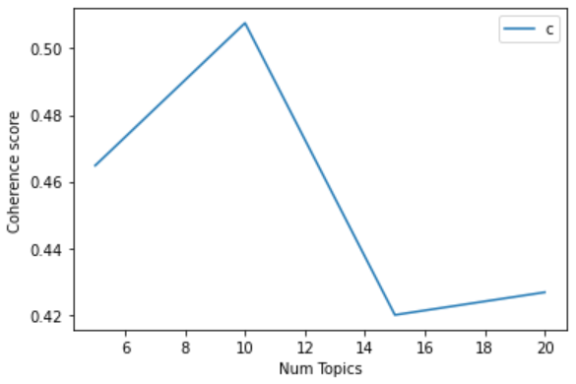

Clustering Inertia: In our data visualization section of the project, we use unsupervised clustering algorithms to generate a clustering of articles based on their topics. Since this model is unsupervised and cannot be improved by repeated runs on different datasets, we instead use what is called an inertia score. Inertia (in clustering algorithms) represents how well a set of clusters represents the actual dimensions of the data we inputted. Lower inertia means that the clustering is a better representation of the data. We use this score, along with the number of clusters, to validate that our clustering algorithm is given the optimal parameters. These parameters change with different sizes of datasets and the topics they discuss.

To find the optimal number of clusters, we consider both the number of clusters generated along with the inertia score. Generally, inertia decreases with an increase in the number of topics (we want low inertia); however, we want to have the least amount of clusters possible. Less clusters means each cluster is more meaningful and unique than the others. Lower inertia means the clusters are well-fitted to the dataset. So the model needs to find the balance between low inertia score and low cluster count, which most often is found using the elbow method. This method is simple: plot inertia vs. cluster count and see where the inertia score tapers off when adding more clusters. When plotted on a graph, this point should look like an elbow if we were to think of the plot as an arm.

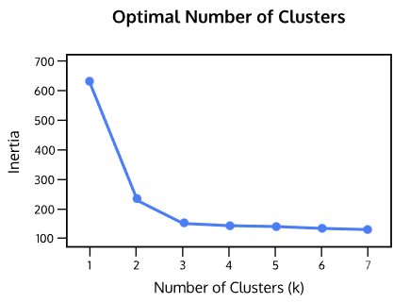

As seen above, finding the “elbow” of the graph would be at k = 3, where an increase to k = 4 produces a negligible decrease in inertia. This method of validation works well for finding a coherent number of clusters to classify our data into.

**User Acceptance Testing:**

User testing was done by the team members by using the model from the perspective of the end user. The team checked to make sure that the model was easy to use, was accurate, and performed as expected. In addition to user testing we got feedback from the sponsor during demos to make sure the model also met their needs. We demoed the model to the sponsor in the same way we tested the model using user testing. This was to ensure that the team and the sponsor were on the same page.

Both the sponsor and the current users have approved the model via user acceptance testing. The model has been demoed to the sponsor to show how the model works from a users perspective. The sponsor approved of the model and its interface. On top of the sponsor's approval, the team has been using the model for several months now and have a good grasp of how to make it as easy as possible to use. Because of this in depth knowledge from a users perspective we were able to create an easy to use model and approve it. In addition to accepting the user friendliness the sponsor approved of the tools used to find bias. User acceptance has also been used to test accuracy on articles that have a large amount of bias to make sure the model does in fact capture that bias, given this is a user based test so there is some form of user bias but when looking at articles with a massive amount of bias it’s a good baseline test.

One of the main areas that required user testing was the visualizations. Since the users themselves are going to be mainly looking at these visualizations to interpret the data it was important to create visualizations that were easy to read and also portrayed the data properly. Both the team members and the sponsor looked over the visualizations extensively to make sure that they met the above criteria. The visualizations have gone through several passes of user acceptance testing and have been approved by the sponsor.

# Staging and Deployment Plans

The team will make the code available in a GitHub(github.com) repository so that the client can access and use the model. The document includes a detailed readme that will include everything that is needed to run the code. This includes things such as what libraries need to be downloaded, what format incoming data needs to be in, how to run the model, what the model will output, and lastly how to interpret the data that is output by the model.

Since the model is dependent on some external libraries, these libraries will be listed in the readme. The information about what the library does, how it’s used in the program, and who made the library will be included in documentation. In addition the commands to install these libraries will also be included in the codebase so that the client can easily install them all.

The readme will also include how incoming data needs to be formatted. It will also include an example so that users can easily follow the example. In addition a template .CSV file will be included so that the user can easily edit just that file.

A few things will need to be checked before running the model, the readme will cover these things. Step by step instructions will be given so that the client can easily check these things and change them if need be. The document will also include instructions on how to run it in multiple environments such as terminal, VS code, and JupyterNotebook.

The readme will also include what the model is outputting. This will include the different variables that it’s outputting along with what these variables are and how they are calculated. This will also include how the raw data is outputted if the client wants just the raw data.

Lastly the document will include how to interpret the data. We have two means of output, a graphical output and a raw data output, we will include how to interpret the data for both these modes of output.

After reading the readme the client should know how to install the model, run the model, and evaluate the data that is being output by the model. The document will be written in a way so that anyone not familiar with the project will be able to read the readme and understand what the model is about and how to use it.

This GitHub repository is all that is needed for the client to use the model. The users of the model are technical professionals so there isn’t a need to package the model with any user interface as the client is using the raw model itself. From the GitHub repository the client will be able to download the model locally to start using it. Once the model is downloaded the user needs to include the .CSV file of URLs in the same directory as the model. Lastly the user needs to update the file name in the .py file so that it matches the .CSV that they are trying to run. Once that is done the model can be run, after it’s done running it will output the data onto the screen.

# Final Prototype Description

### Problem Statement

A major threat to information security is dissemination of biased media, as it shapes the minds of readers unknowingly towards the author’s stance on a topic. If readers are uninformed, they are at the will of the author as to what they will feel about a certain topic, especially if they trust that source to be unbiased. Our probabilistic model aims to give the media analysts and professionals who use it a unique look into the ecosystem of the articles around a certain time frame and set of topics. The users will be able to gather meaningful insight into how single articles as well as sources contribute to the overall sentiment of a topic, and analyze trends that emerge from the large interacting body of articles. This model will provide a way for analysts to see how certain sources or articles try to sway their audience, and the repeated patterns of bias that sources use.

The model will take in a corpus of articles on various or the same topic, and give a graphical and data-centric presentation of the subjectivity and sentiment around certain topics within an article. We can then make comparisons between articles that talk about the same topic, and visualize their similarities and differences. The purpose of the model is to provide the user with visuals that explain the topic space of the articles and the similarities or differences that articles have in the topic space. The model also utilizes sentiment and subjectivity to help users understand an author’s bias on certain topics or on the article as a whole.

### Solution approach

Model 1 will be our lowest-level tool for building the overall model. It will provide valuable insights into the sentiment of a single news article, as well as around the specific topics included in the article. We will be utilizing free NLP tools including Textblob for localized sentiment analysis, Spacy for web scraping our articles and providing the Textblob library, and Gensim for single-article topic modeling. This section of the ML pipeline will read in all of the articles using a URL list provided by the user, and scrape the text and title of every article possible. It then performs sentiment analysis and topic modeling on every article to generate the topic space. The output of this model is a list of topics that best fits the articles inputted, as well as the sentiment value of each article and the sentiment value of each article towards each topic it discusses.

Model 2 will take our analysis of single articles and compare/sort them by topic, as well as providing meaningful insight into the relationships between articles. The data is being transformed into the relationships between articles in order to pass into the third model, which organizes the articles and displays their relationships, as well as providing the per-article data we create. This stage of the ML pipeline is responsible for creating new, specific data objects that will be used to generate visualizations of the article ecosystem. It takes the data gathered from the previous model including sentiment, topic models, and article text to create the data objects. These objects focus on the relationship that articles share with their topics, and how they relate to other articles.

The final model is responsible for creating and displaying the article ecosystem using visualizations and organized relational data. The purpose of this model is to give the users understandable visualizations that they can use to interpret the data from the previous two models. The main function of this model is to generate those visualizations and allow the user to interact with them. The specific visualizations are explained further below in this section.

For understandability, the following sections were split by the function that they perform and not the model that they belong to. Directly below is a model of our ML pipeline and the model description.

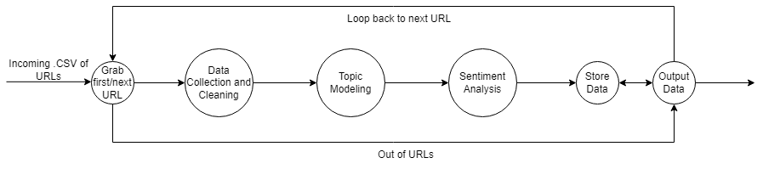

Image 1: Model Pipeline

## Data Collection

## Functions and Interfaces Implemented

The model takes in a .CSV file filled with URLs. The incoming .CSV file should have one column named “Address”, every row within this column is a URL link to the article that needs to be scrapped. A loop is used to loop through each of these URLs, sending them through the model one by one.

A library named Newspaper3k(newspaper.readthedocs.io) is used to scrape the data from the web. The library is authored and maintained by Lucas Ou-Yang. Newspaper3k can scrape from 10+ different languages and can even auto detect languages. It extracts from html and can extract things such as text, top image, and all other images in the article. Once it’s extracted it can then go through the text and extract information such as keywords, summary, author, and google trending terms. The model uses Newspaper3k to gather the main text and title of every article to store in a dataframe.

Newspaper3k also uses a lot of python-goose’s parsing code. Python-Goose(github.com/grangier/python-goose) is a library that extracts information such as main text from an article, main image of an article, article descriptions, and more. Python-Goose was rewritten by Xavier Grangier.

## Preliminary Tests

Testing was done to make sure that the data was in the correct format and wasn’t adding garbage. This was primarily done manually, scraping a website and comparing what was scraped vs what was on the website. After testing and adjusting we were able to get rid of a lot of the garbage such as ads, links to other news articles, videos and social media posts, etc.

## **Topic Modeling**

## Functions and Interfaces Implemented

Topic modeling is being done on each article in the corpus. Gensim’s (radimrehurek.com/gensim/) topic modeling tool is used to extract the optimal number of topics for the article corpus as well as the major topics for each article. The topics are represented by a list of words from highest to lowest representativeness of any given topic. Topics are compared with each other to find similar topics that might indicate a meta topic that spans multiple articles. An example of this might be an article about “Quarantine” and an article about “Covid” might be representative of a meta topic called “The Covid Pandemic”. This will help the user understand the overall sentiment towards meta topics. We use this data to generate an optimal list of topics where every article contains at least one of the topics in the list.

### Preliminary Tests

A Comprehensive score is taken on a wide array of LDA(Pritchard, Jonathan K, 2000) models with a variety of tuned hyper parameters to find the mode comprehensive topic model of a given article. Manual testing of topic generation is also performed to make sure the topics are comprehensive of the article space and understandable.

## Sentiment Analysis

### Functions and Interfaces Implemented

The model uses SpaCy’s(spacy.io) sentiment analysis tool to run a comprehensive analysis on all of the articles and topics within the articles. After it receives a list of relevant topic words from Gensim’s(radimrehurek.com/gensim) LDA model(Pritchard, Jonathan K, 2000) we run sentiment analysis on each topic word and return a list of sentiment scores. Then we multiply each score by its associated topic weight (how prevalent the word is in an article) given by the LDA model. Adding all scores within a topic together gives us a new sentiment score based on the weighted sentiment of each representative word within the topic. This new score will function as a positive or negative opinion of a topic which can then be compared and contrasted with other articles' topics. The model then runs a comprehensive sentiment analysis on the entire article for a better understanding of the author's bias in their style of writing, or over all of the associated topics.

### Preliminary Tests

We ran accuracy tests with TextBlob on the BASIL(Zhang, Xinliang, 2022) dataset. We wanted to ensure that Textblob could accurately provide a sentiment score on news data in particular. Sentiment analysis has also been run on a working dataset provided by the client, with a set of 30 and 130 article URLs for basic performance testing.

## Data Visualization

### Topic Space and Topic Sentiment Visuals

Multiple plots are used to help visualize the topic space and how articles relate. The model uses topic distance maps to show similarity and differences between the generated topics. It also uses various heatmaps and scatter plots to visualize the document distribution in the topic space, which shows the reader how documents are distributed amongst the generated topics.

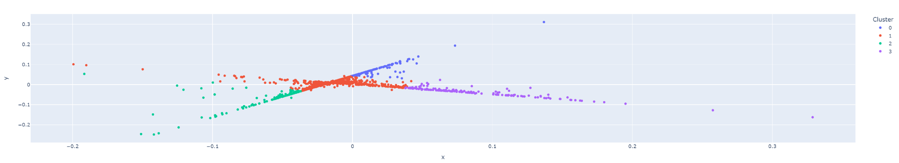

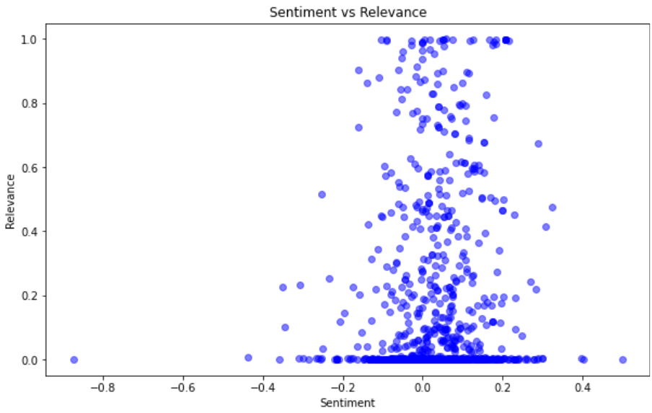

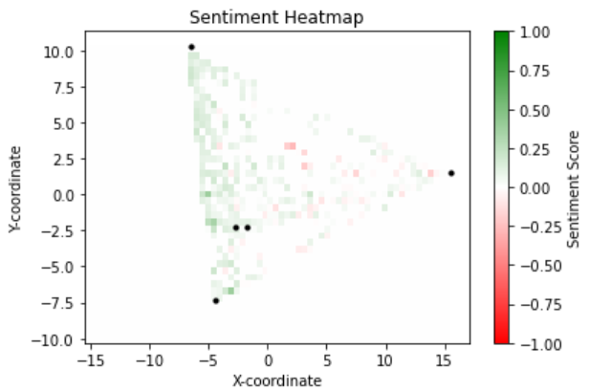

### Main Topic Sentiment Analysis

Generates a plot of all articles sorted by their main topic, and plotted along their sentiment values. Has a bubble plot (to see individual articles) as well as a box plot (to see overall bias distribution on a topic) version.

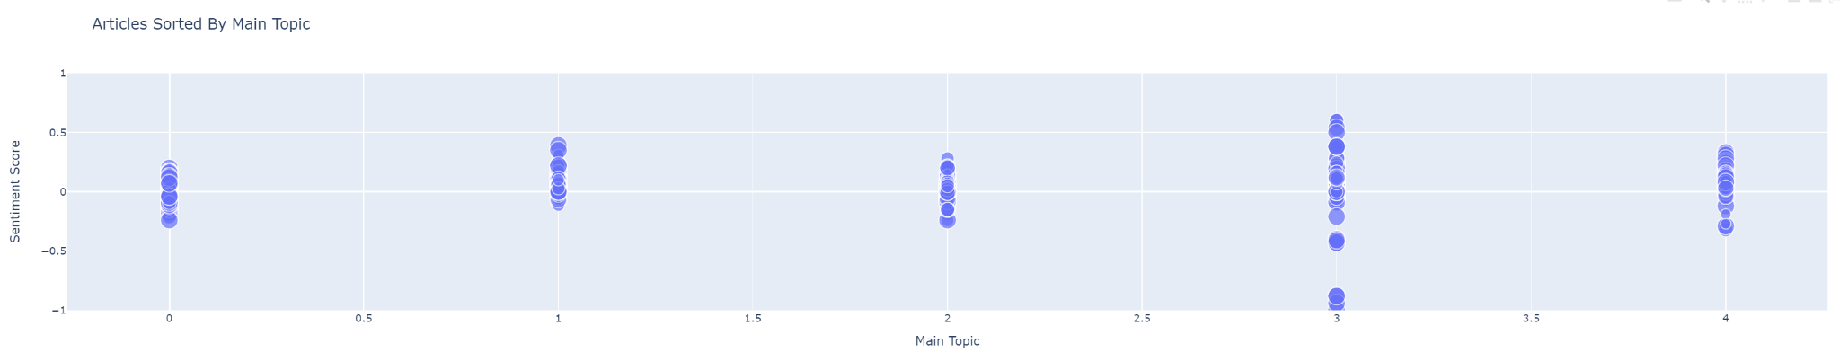

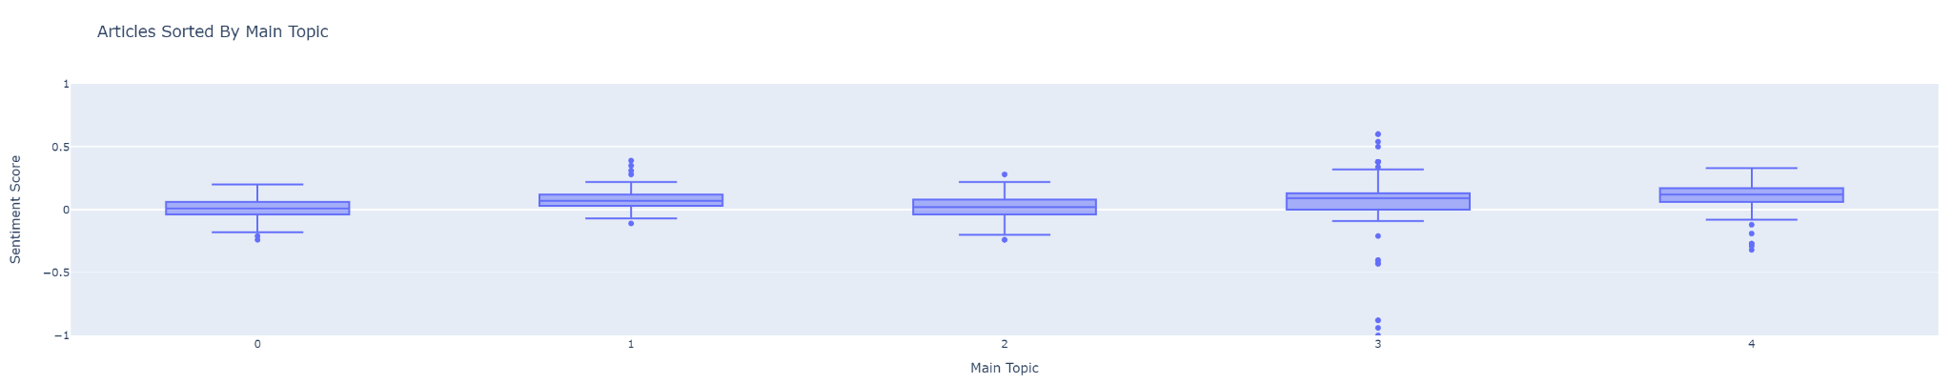

### Topic Subjectivity vs Sentiment

Generates a 2D plot of all articles with that topic number as their main topic, plotted with their sentiment scores and their subjectivity scores along with an associated word cloud for easy comprehension of the topic visualized. This shows the reader how subjective an article is about a specific topic, and the bias on that topic. It also generates topic word clouds that show the major words in a topic, to better understand what the topic discusses.

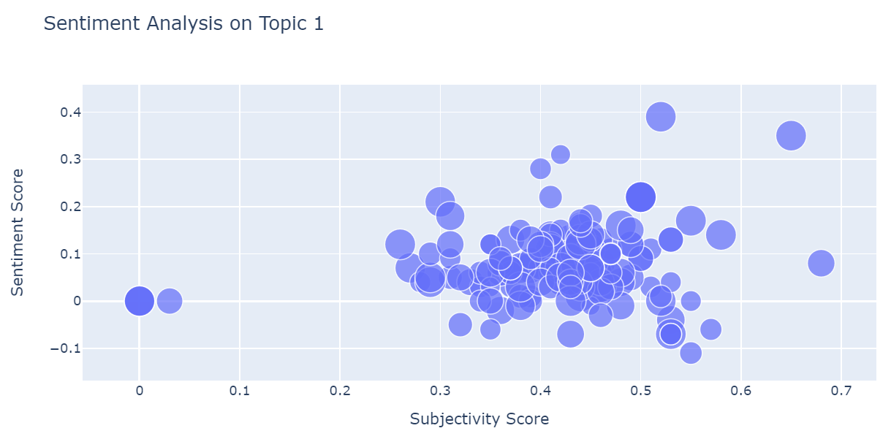

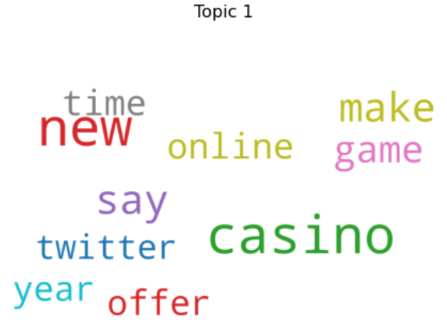

### TSNE Dimension Reduction and Clustering

Generates a 2D bubble plot using t-SNE of all topics clustered by their topic relevance. This allows the user to see the entire environment of what's being talked about and compare topics between articles. Also generates a 3D topic x sentiment plot that shows the topic space in 2D, with the z-axis being the sentiment values of the articles. This shows both how articles differ in topics, but also differ in their opinions/bias.

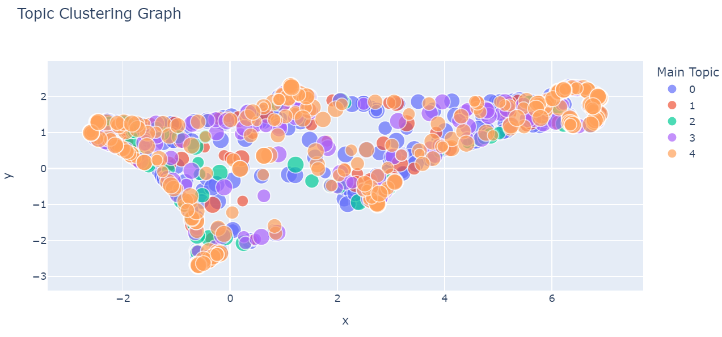

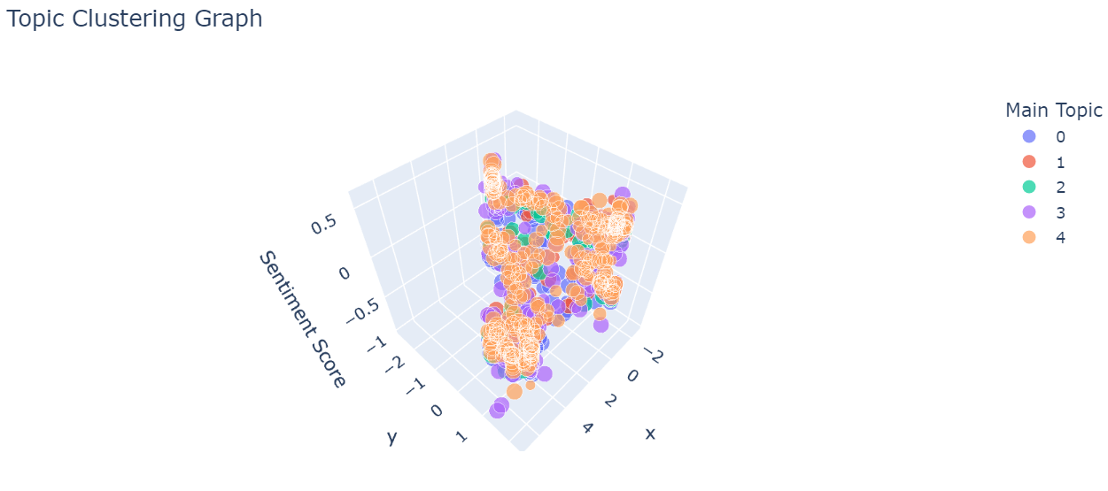

### K-Means Clustering

Generates a 2D bubble plot using PCA and kmeans clustering of all topics clustered by their topic relevance. This allows the user to see the entire environment of what's being talked about and compare topics between articles. Also generates a 3D topic x sentiment plot that shows the topic space in 2D, with the z-axis being the sentiment values of the articles. This shows both how articles differ in topics, but also differ in their opinions/bias.

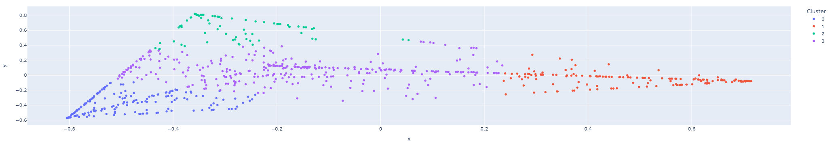

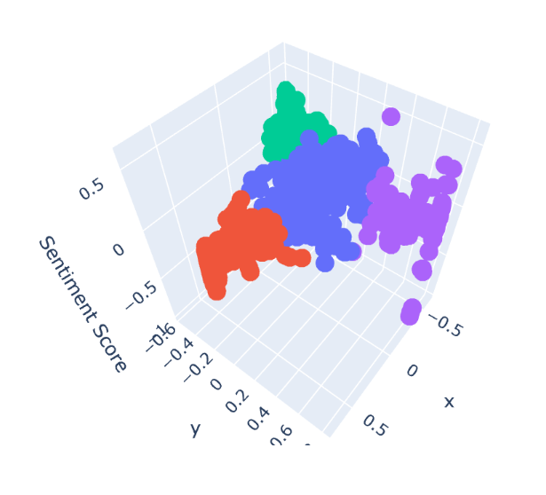

# Conclusions and Future Work

## Conclusions

The Probabilistic News Model is currently at a fully functioning state. It has been tested and verified on several datasets of varying sizes, and the model produces valid results. As of the time of this report, the project is a set of Jupyter notebooks that run python code to produce the model. The model still has room for improvements and changes, as discussed in the “Future Work” section below.

## Future Work

Everything the team planned on achieving by the end of the project was achieved. There are however some areas in which the project can be improved upon.

One of these areas is a user interface. As of now the project is run directly within a Jupyter Notebook. The project can be improved by creating a user interface so that analysts who aren’t as tech savvy have an easier time using the model. It could also be run through an executable rather than a Jupyter notebook, for ease of use. The sponsor has mentioned that a user interface may be a good project for a future capstone class to create.

Being that the model is modular there is always the ability to test out new libraries and tools. If a new revolutionary tool comes out it would benefit the model to swap that into the program. This goes for any of the tools currently being used in the model. For example, a new revolutionary sentiment analysis tool could result in a better accuracy, or a new web scraping tool could result in more accurate web scraping.

Another area in which the model could be improved is the ability to guage similarity between articles. This was talked about as potentially being added into the model but it was decided to not add it as it wasn’t as relevant as the other features. It could still be useful in niche cases to have this feature added.

Being that this is a research project the team potentially has the ability to create a research paper. The project is robust enough to have that potential and the team has discussed the idea of creating a paper.

# Repository Information

## Repository URL

<https://github.com/WSUCapstoneS2023/Media-Bias-Prediction-Model>

## Last Commit

Date: 11/17/2023

Commit Description: bug fix on tsne– fixed a bug where the number of topics would sometimes be wrong

URL: <https://github.com/WSUCapstoneS2023/Media-Bias-Prediction-Model/commit/d984cecb00759a80d2a85e5980f713ca0142a56b>

## Contributors Names and Github Usernames

Gabriel Sams: gabrielsams

Deven Biehler: Deven-Biehler

William Hiatt: William-Hiatt

# References

Anderson, Martin. “MIT: Measuring Media Bias in Major News Outlets with Machine Learning.” Unite.AI. Unite.AI, December 10, 2022. <https://www.unite.ai/mit-measuring-media-bias-in-major-news-outlets-with-machine-learning/>.

“Army Cyber Institute (ACI) Home.” Army Cyber Institute (ACI) Home. Accessed April 20, 2023. https://cyber.army.mil/.

“Balanced News via Media Bias Ratings for an Unbiased News Perspective.” AllSides. AllSides, October 20, 2022. <https://www.allsides.com/unbiased-balanced-news>.

Chen, Wei-Fan, Benno Stein, Khalid Al-Khatib, and Henning Wachsmuth. “Detecting Media Bias in News Articles Using Gaussian Bias ... - Arxiv.” Detecting Media Bias in News Articles using Gaussian Bias Distributions. Accessed April 20, 2023. <https://arxiv.org/pdf/2010.10649.pdf>.

“Gensim: Topic Modelling for Humans.” Radim ÅehÅ¯Åek: Machine learning consulting, December 21, 2022. <https://radimrehurek.com/gensim/>.

“Let's Build from Here.” GitHub. Accessed April 20, 2023. <https://github.com/>.

“Media Bias/Fact Check News.” Media Bias/Fact Check, July 22, 2021. <https://mediabiasfactcheck.com/>.

“Pandas.” pandas. Accessed April 20, 2023. <https://pandas.pydata.org/>.

“Newspaper3k.” newspaper3k. Accessed April 24, 2023. <https://newspaper.readthedocs.io/en/latest/#>

Pritchard, Jonathan K, Matthew Stephens, and Peter Donnelly. 2000. “Inference of Population Structure Using Multilocus Genotype Data.” Genetics 155 (2): 945–59. https://doi.org/10.1093/genetics/155.2.945.

Samantha D'Alonzo and Max Tegmark, “Machine-Learning Media Bias,” arXiv.org (Dept. of Physics and Institute for AI &amp; Fundamental Interactions, August 31, 2021), <https://arxiv.org/abs/2109.00024>.

“Spacy · Industrial-Strength Natural Language Processing in Python.” · Industrial-strength Natural Language Processing in Python. Accessed April 20, 2023. <https://spacy.io/>.

“Simplified Text Processing.” TextBlob. Accessed April 20, 2023. <https://textblob.readthedocs.io/en/dev/>.

Zhang, Xinliang. 2022. “Launchnlp/BASIL.” GitHub. July 17, 2022. <https://github.com/launchnlp/BASIL>.

# Acknowledgements

We would like to express our gratitude to the National Security Innovation Network (NSIN) and Iain Cruickshank with Army Cyber Institute for their support and collaboration in making this project possible.​ Iain dedicated many hours to helping us with this project. He was always available for feedback and provided great feedback for the team to implement.